**Design Documentation for PINit by Jean-Philippe McCluskey**

Last updated: Sunday 7th of April, 2019

**Objective:**

This project is designing a Pinterest clone application for Tread interview using: frontend (React/Redux) + backend (Express/NodeJS) + DB (mongoDB).

**Functionalities:**

As an unauthenticated user:

- I can login with GitHub.

- I can browse other users’ walls of images.

As an authenticated user:

- I can link to images.

- I can delete images that I’ve linked to.

- I can see a Pinterest-style (infinite scrolling) wall of all the images I’ve linked to.

- I can generate shortened urls of images that I’ve linked to.

**Application Architecture:**



**React App Pages:**

**index.js**

The index file serves as setup page for the redux store and renders App.js component

**App.js**

The App component is where I setup routing with react router for the application

**Header.js**

The header will contain 3 buttons (left to right):

* “PINit” that takes you to index.js page from anywhere
* “Add Pin” that only shows if user is authenticated and takes you to AddPin.js where the user can create a new pin
* “My Wall” that only shows if user is authenticated and takes them to Wall.js
* “Login with Github” that takes you through the authentication with github and back to index.js. It changes to a logout button if the user is authenticated.

**Wall.js**

This is where users can view pins by users.

**AddPin.js**

This page contains 2 text boxes and a button:

* “Title” text box where the user can add a title for the image they are linking to.
* “URL” text box for the url of the image that is being linked to.
* “Add Pin” button to add the photo to the database

The post will also be set to database with users id.

**Express/NodeJS API:**

This api communicates between the react app and the database with https/ajax requests containing JSON.

npm install --save express

**MongoDB Database:**

Use mongoDB database to store all the information on application.

1. A table for Pins:

* Image URL
* Shortened URL
* Title
* User ID
* (description)

1. Table for Users:

* User name
* User id

**Running:**

1. Run React app on localhost:3000
2. Express server on localhost:PORT

the port will be dynamically made by Heroku in production OR 5000 for development

1. MongoDB server on localhost:####

**Appendix Resources:**

Login With github:

* <https://developer.github.com/apps/building-oauth-apps/creating-an-oauth-app/>
* <https://auth0.com/docs/connections/social/github>

Mongo DB:

* <https://docs.mongodb.com/>

**Appendix Pinterest Photos:**

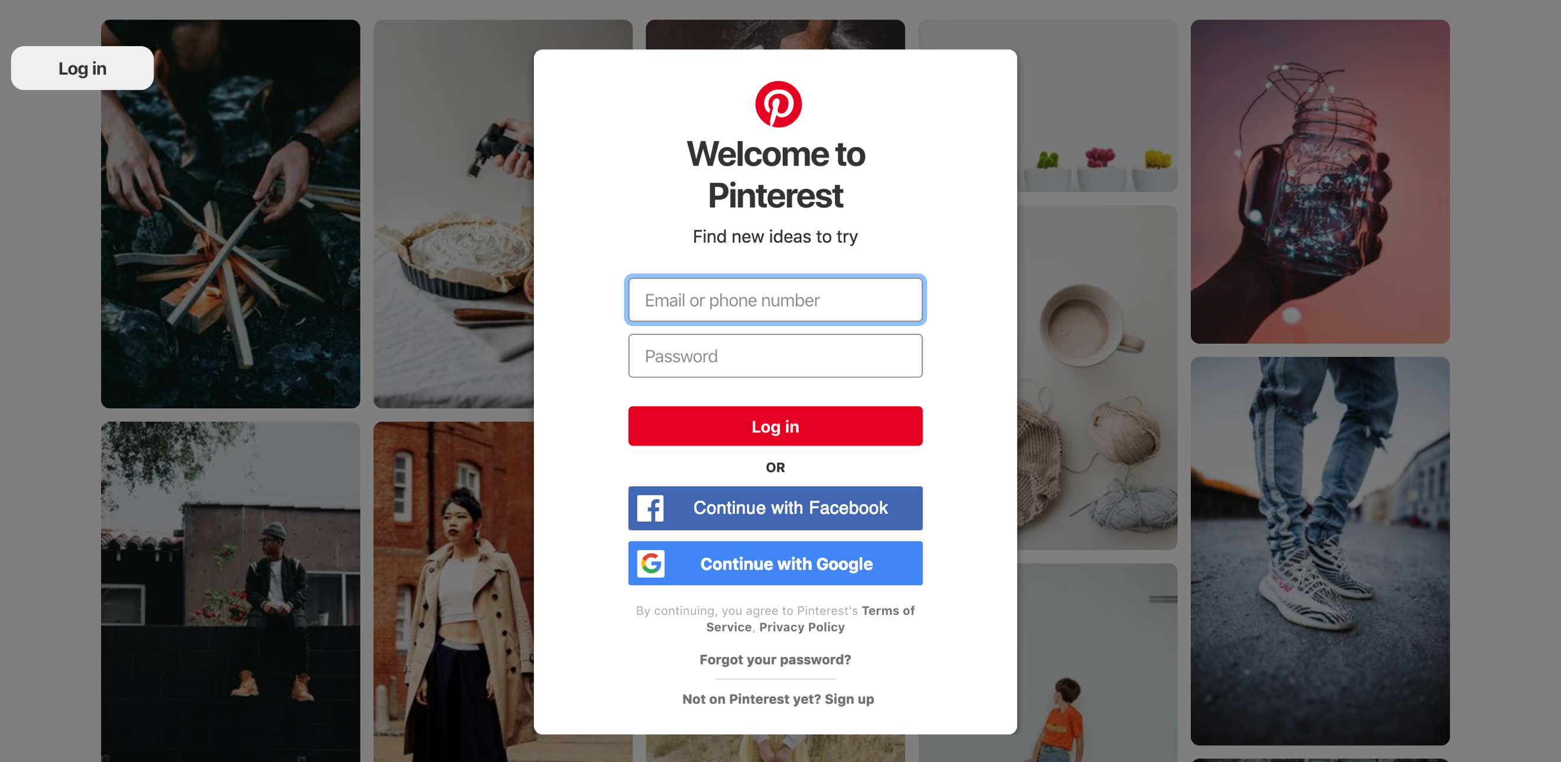

Figure 1: login page

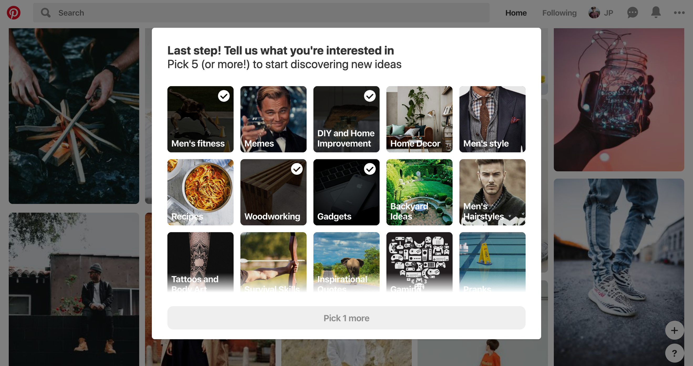

Figure 2: choose interests page4/5

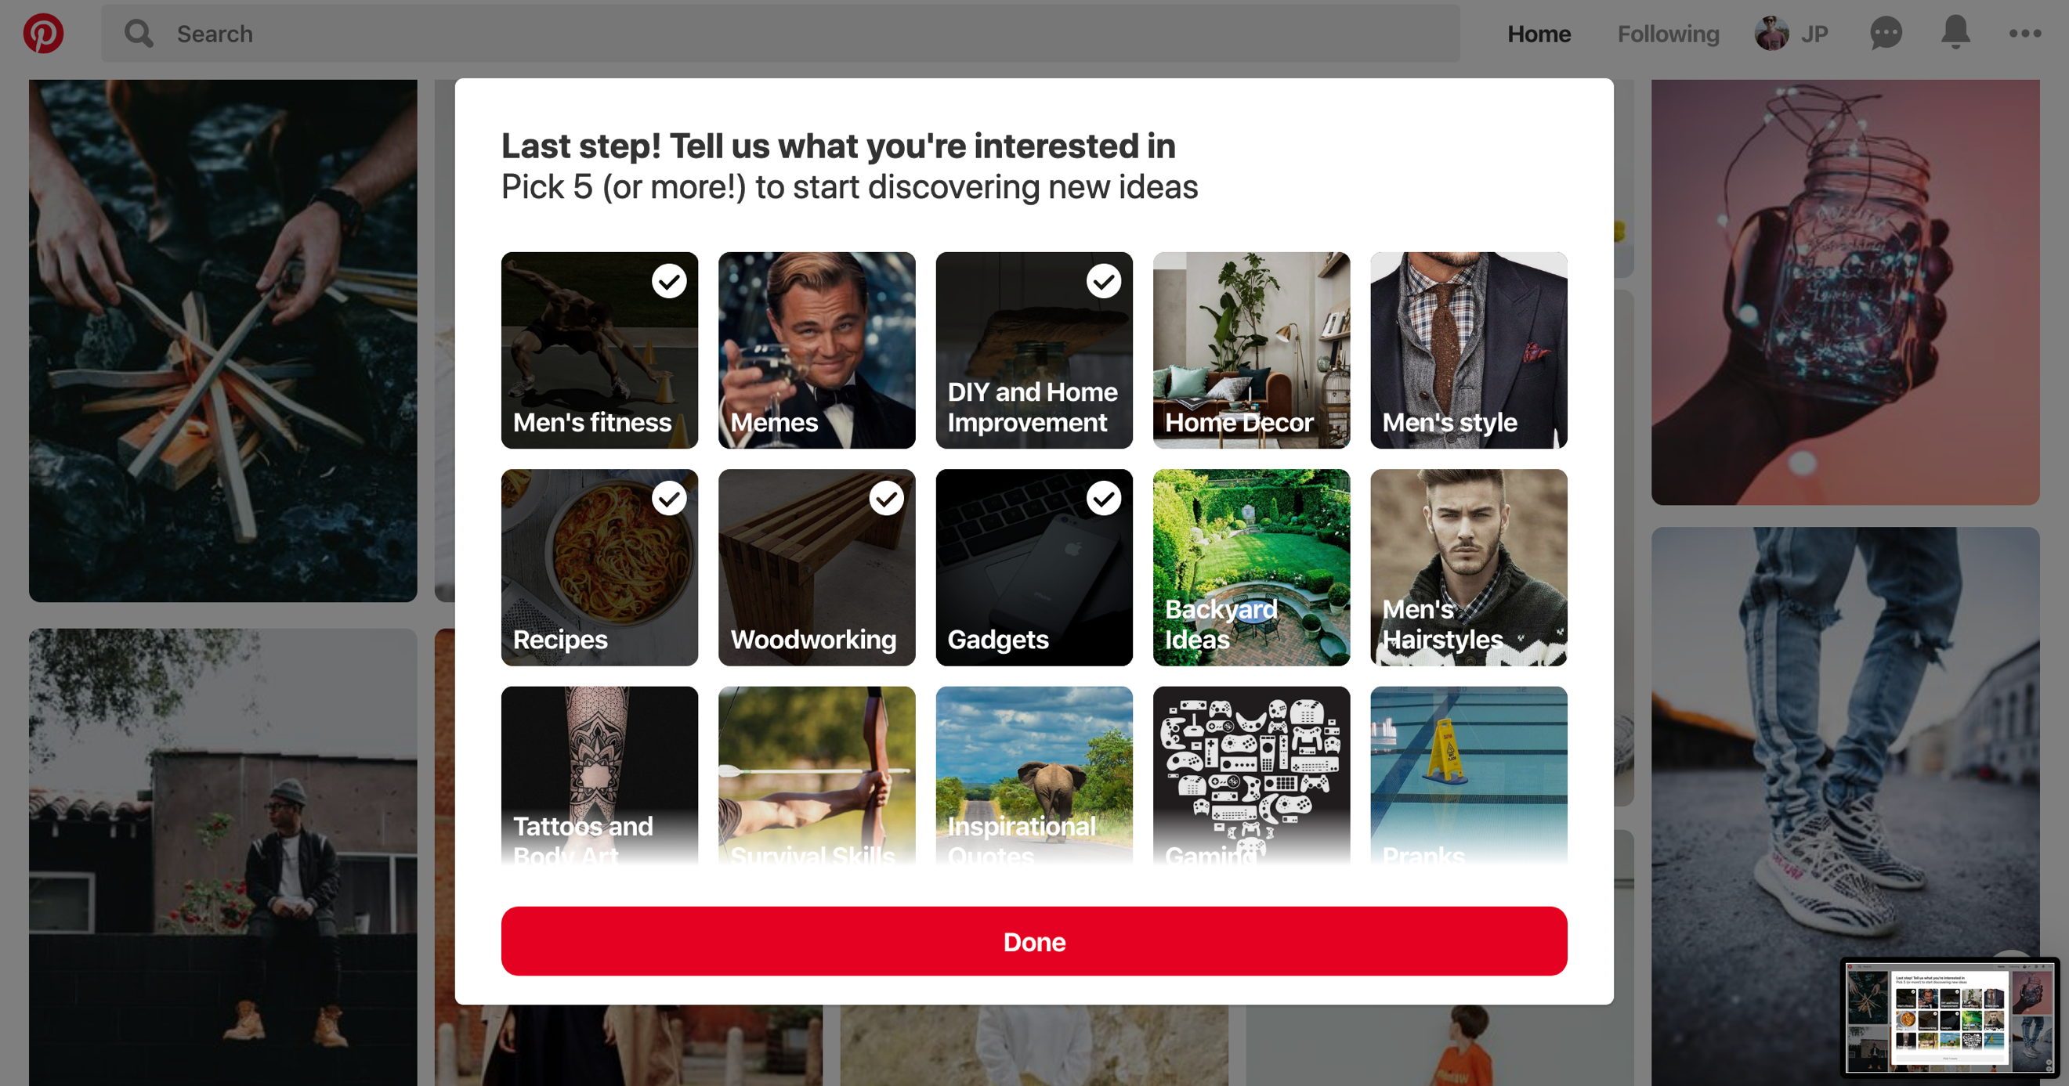

Figure 3: choose interests page5/5

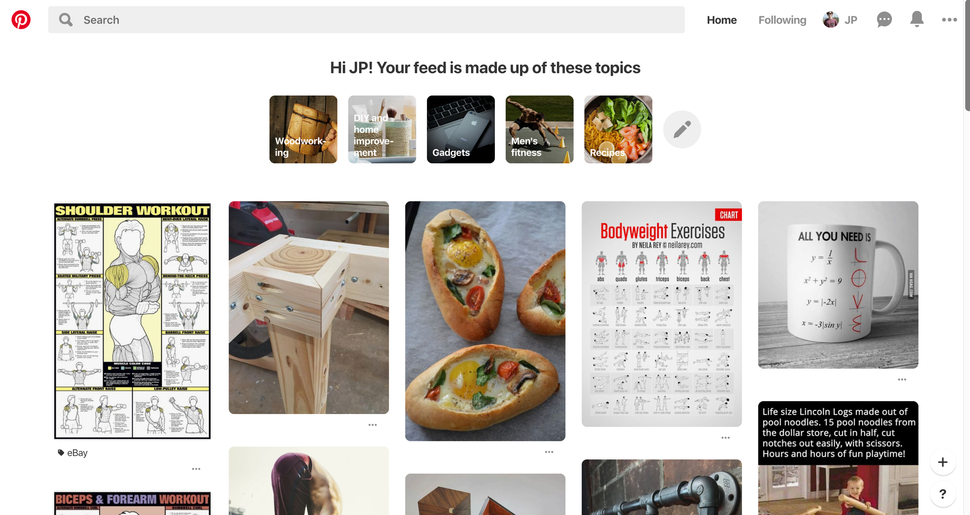

Figure 4: home page

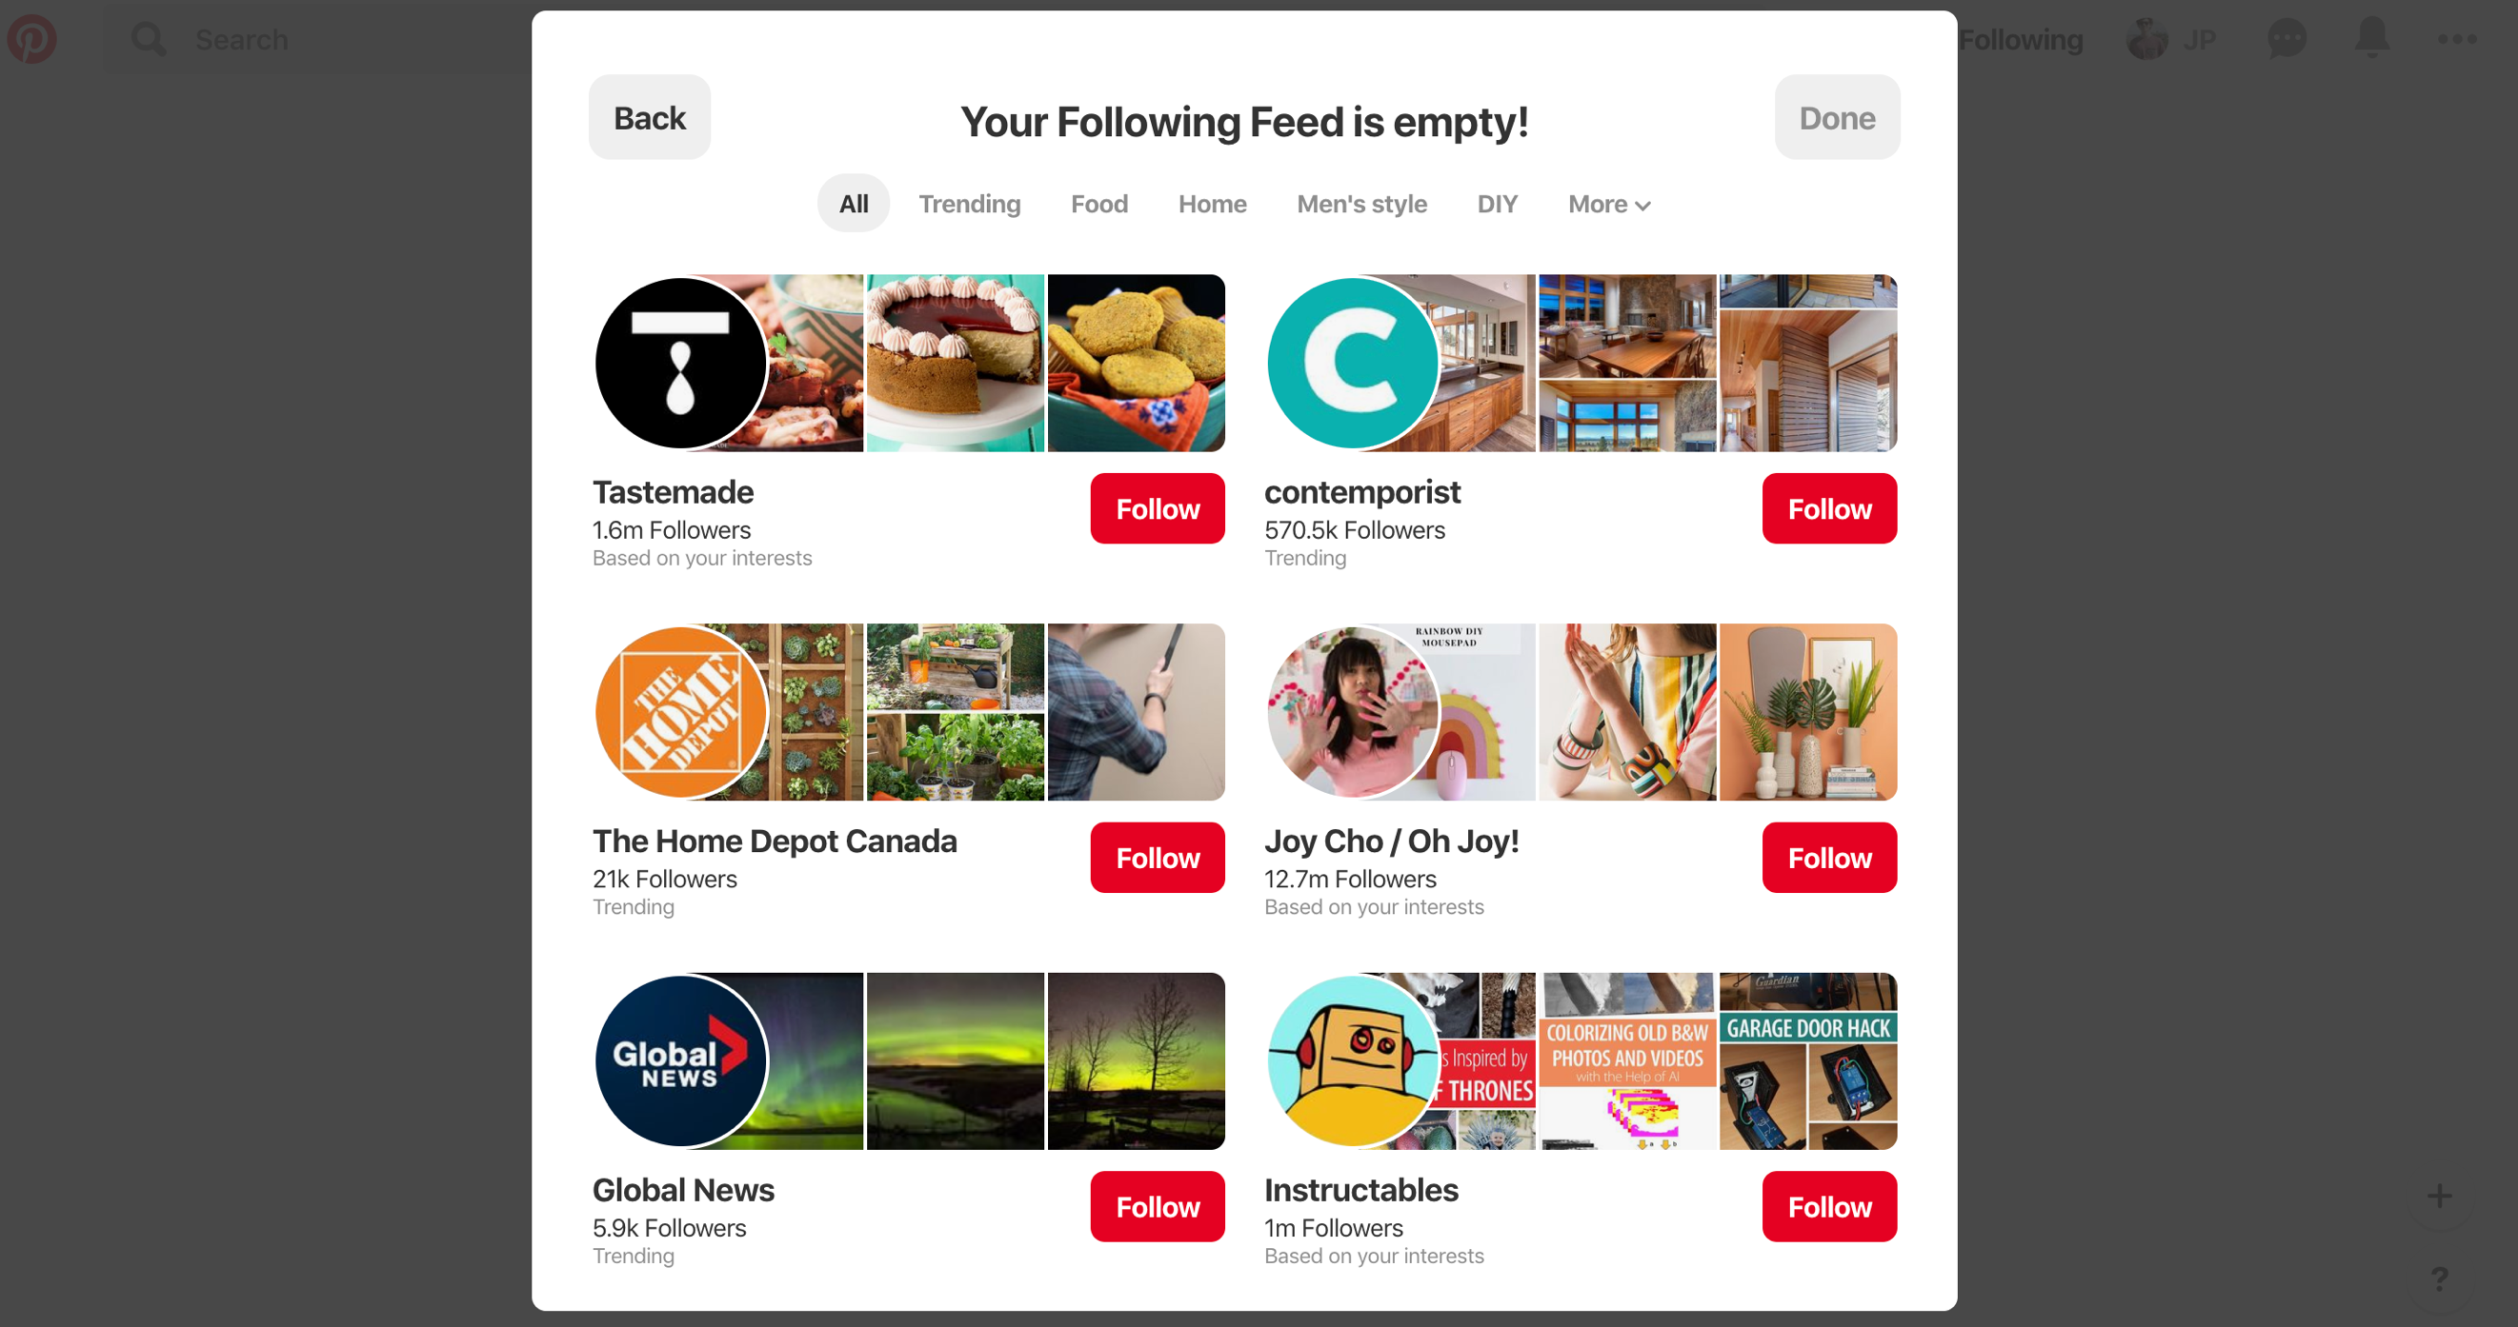

Figure 5: choose follower page

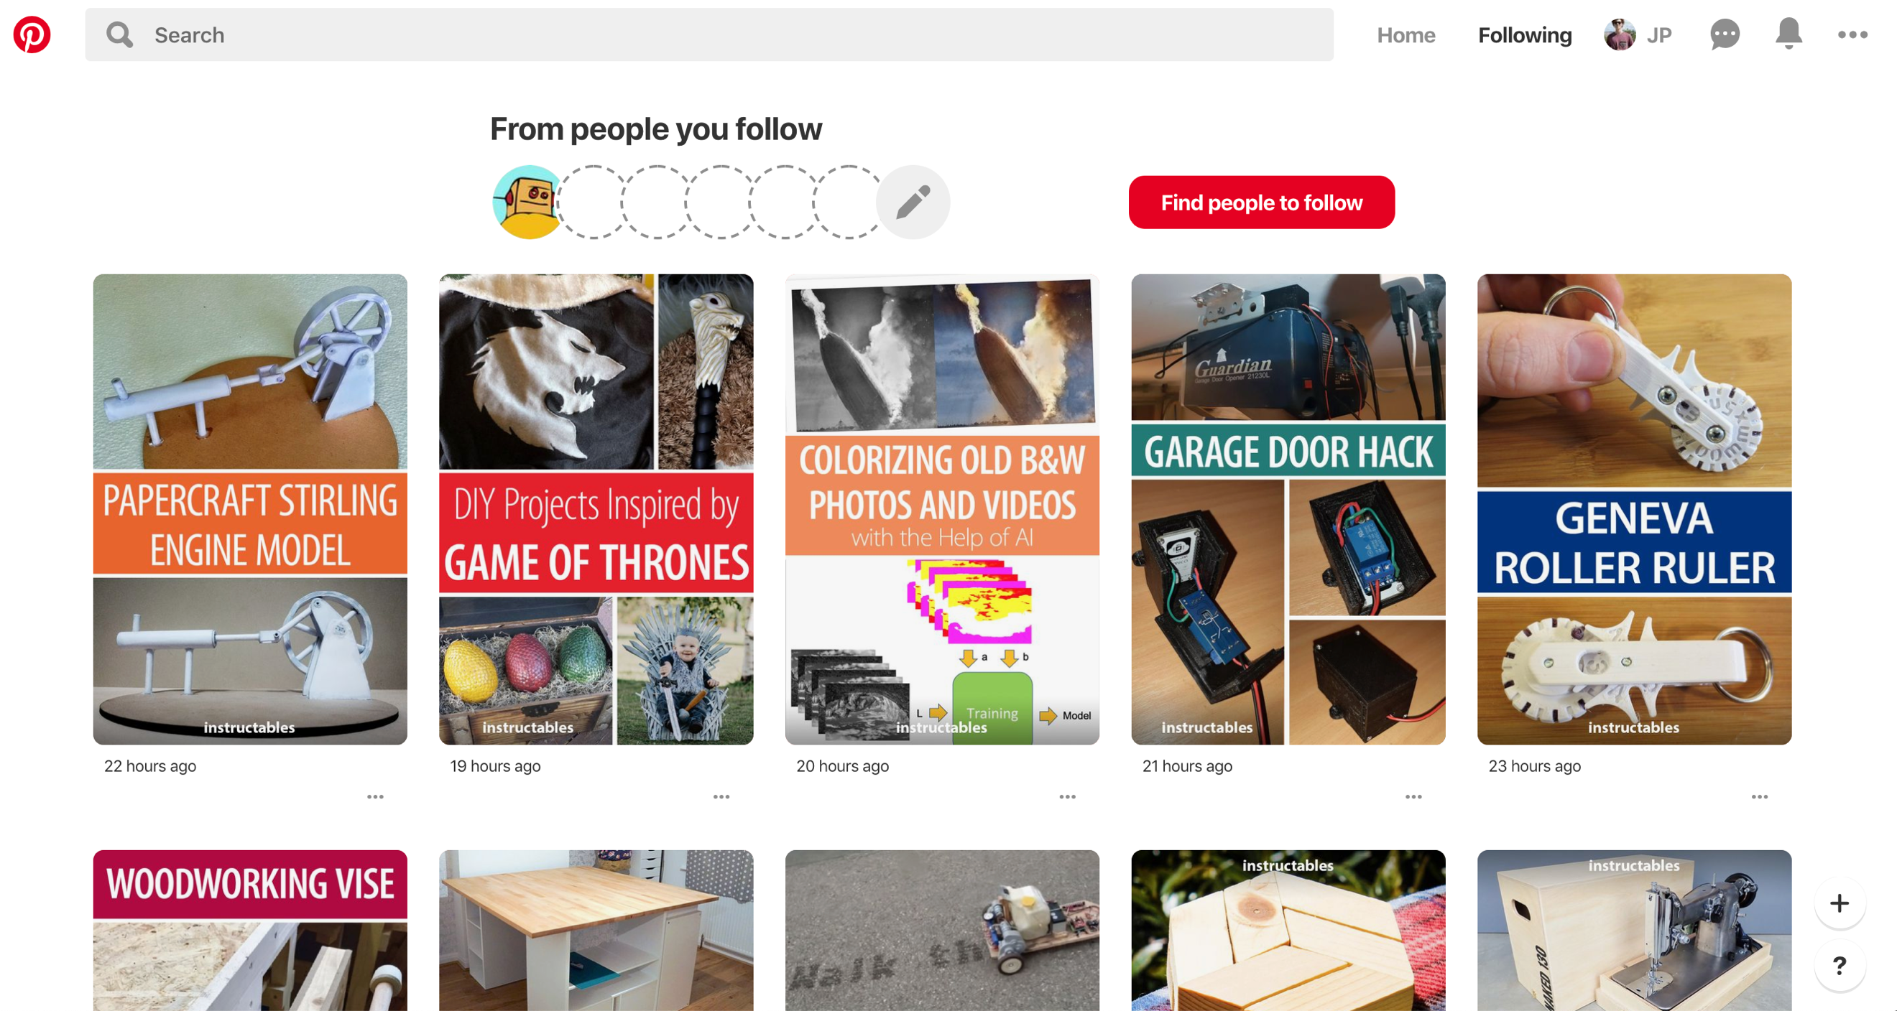

Figure 6: follower page

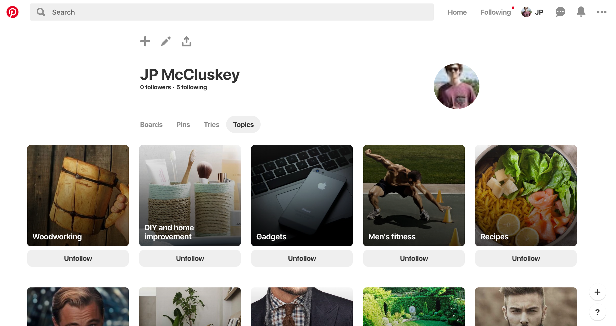

Figure 7: profile page

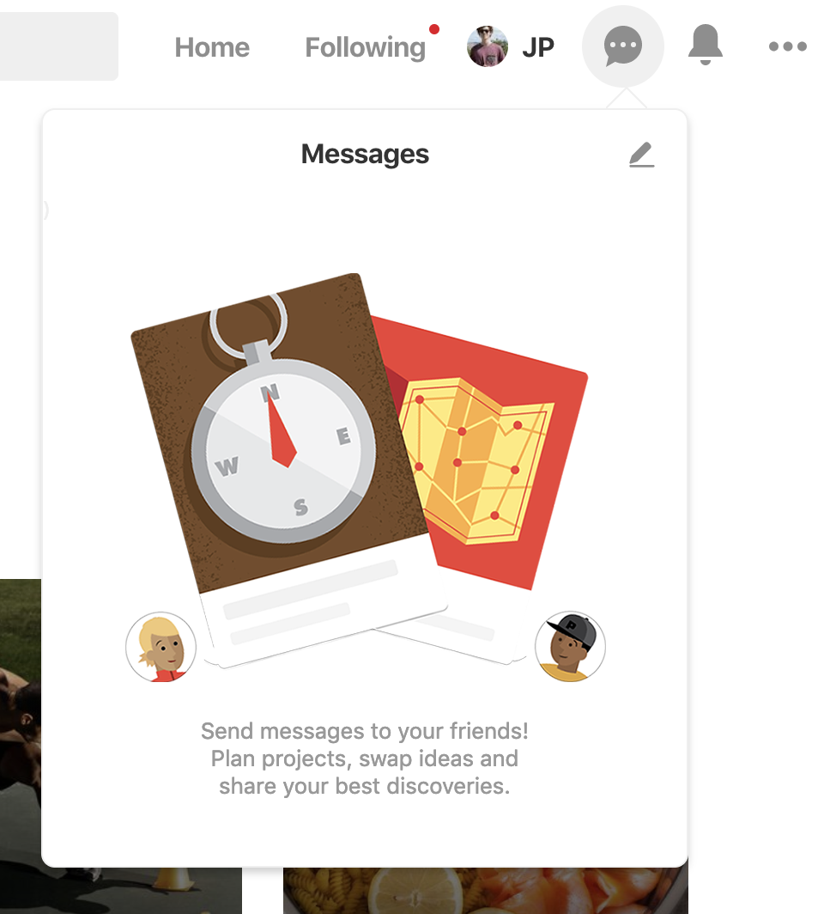

Figure 8: messaging widget

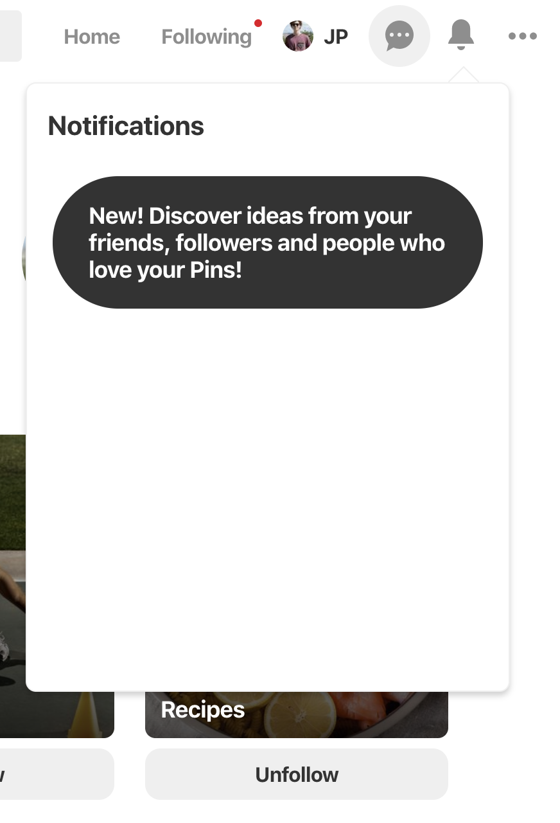

Figure 9: notificationn widget

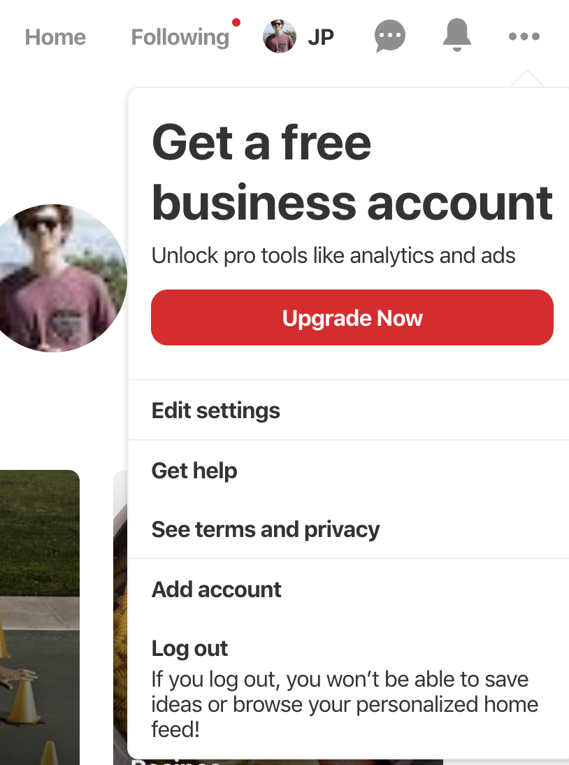

Figure 10: settings widget

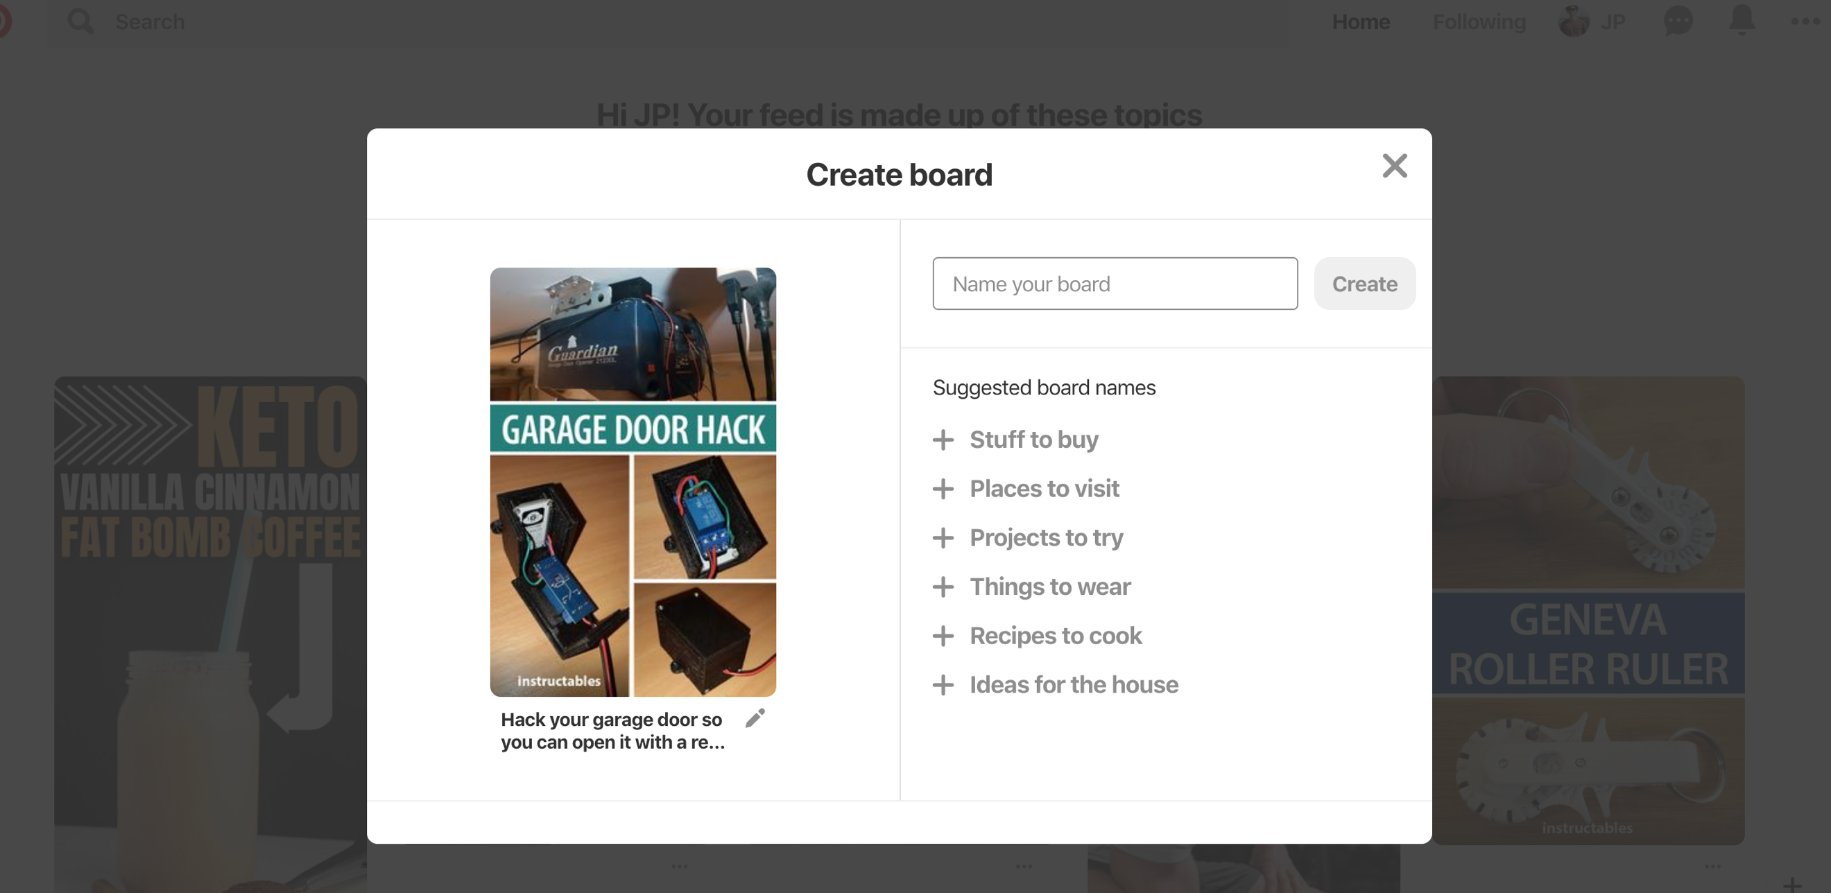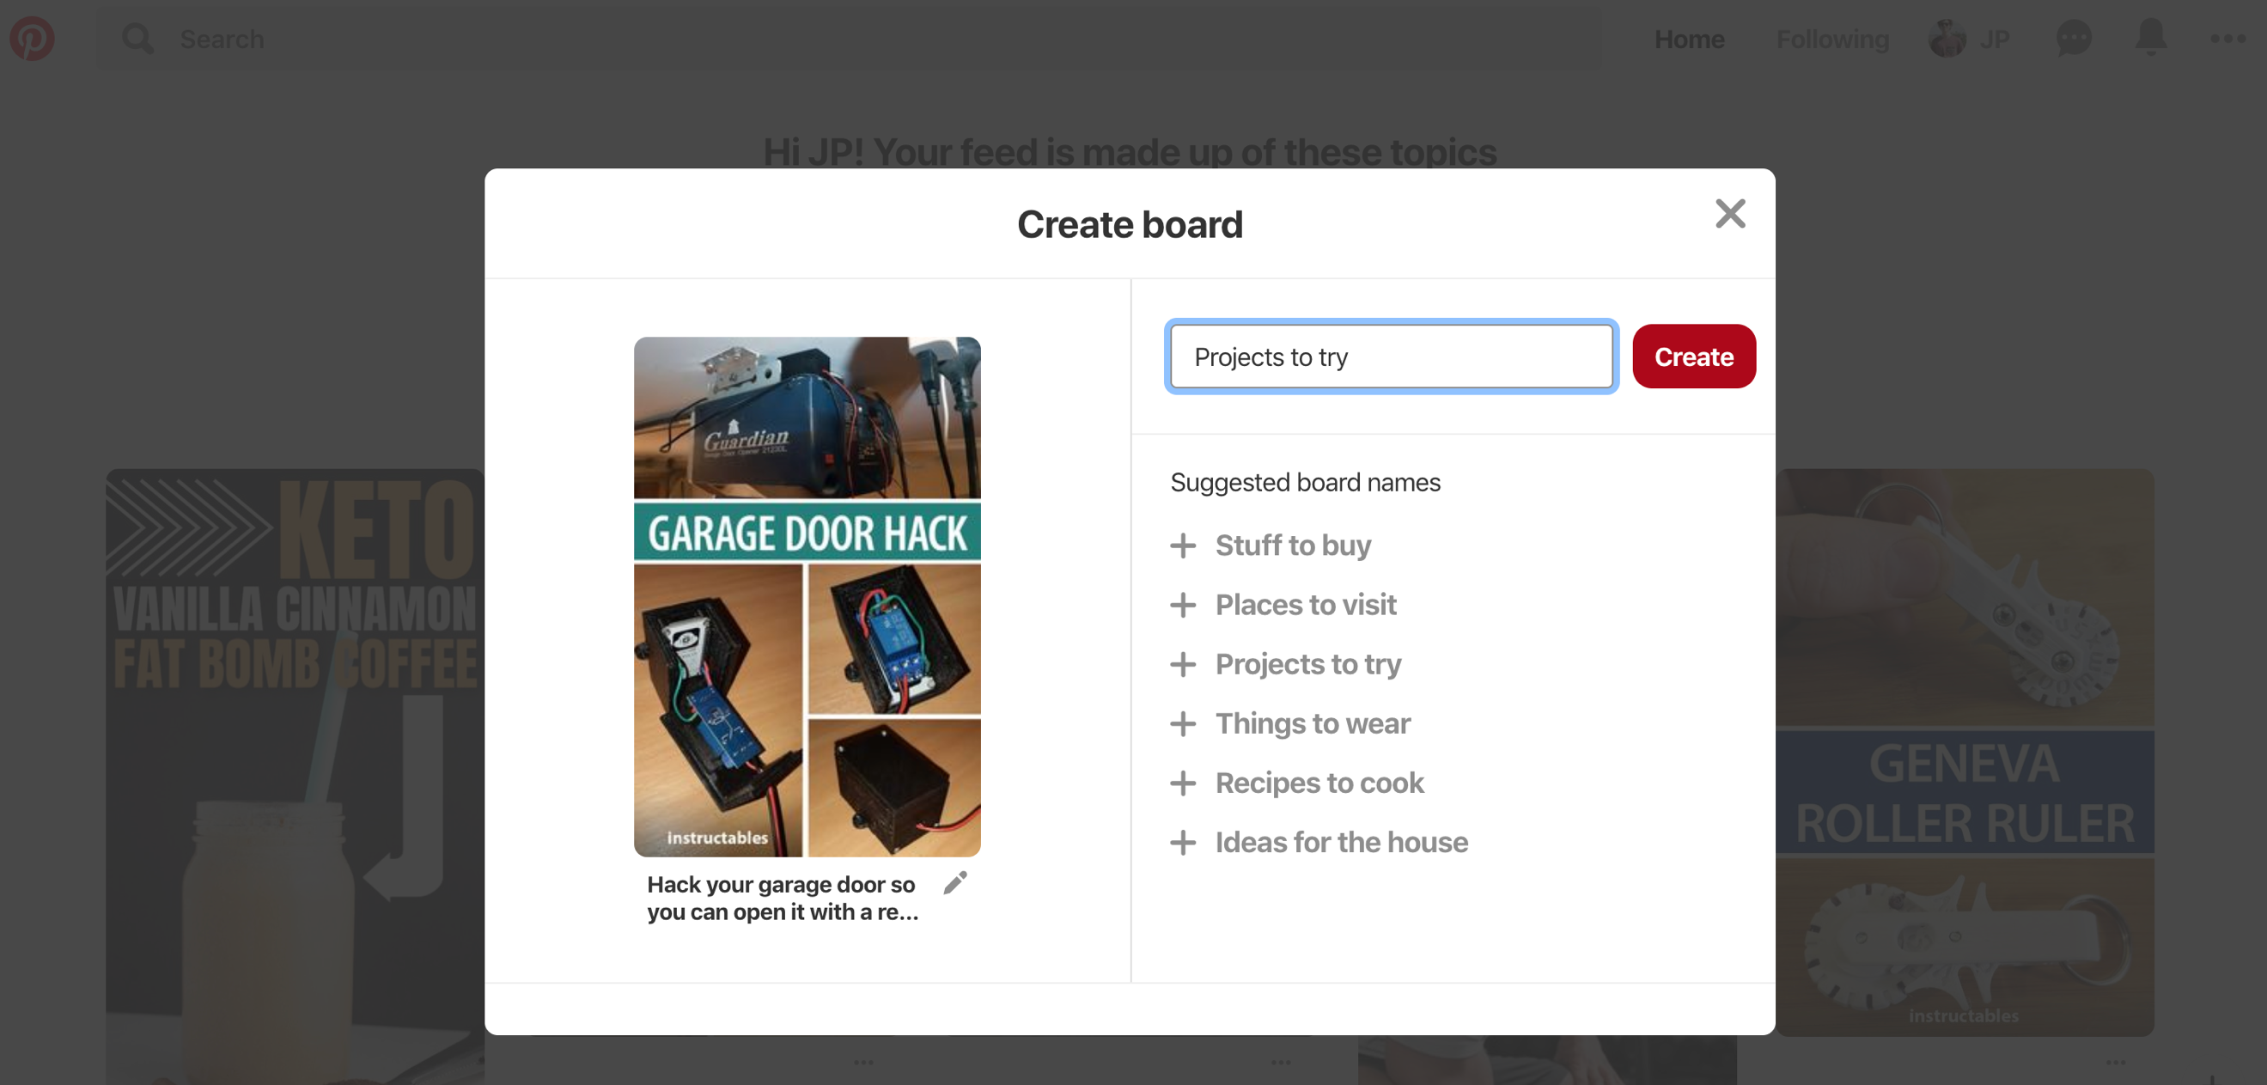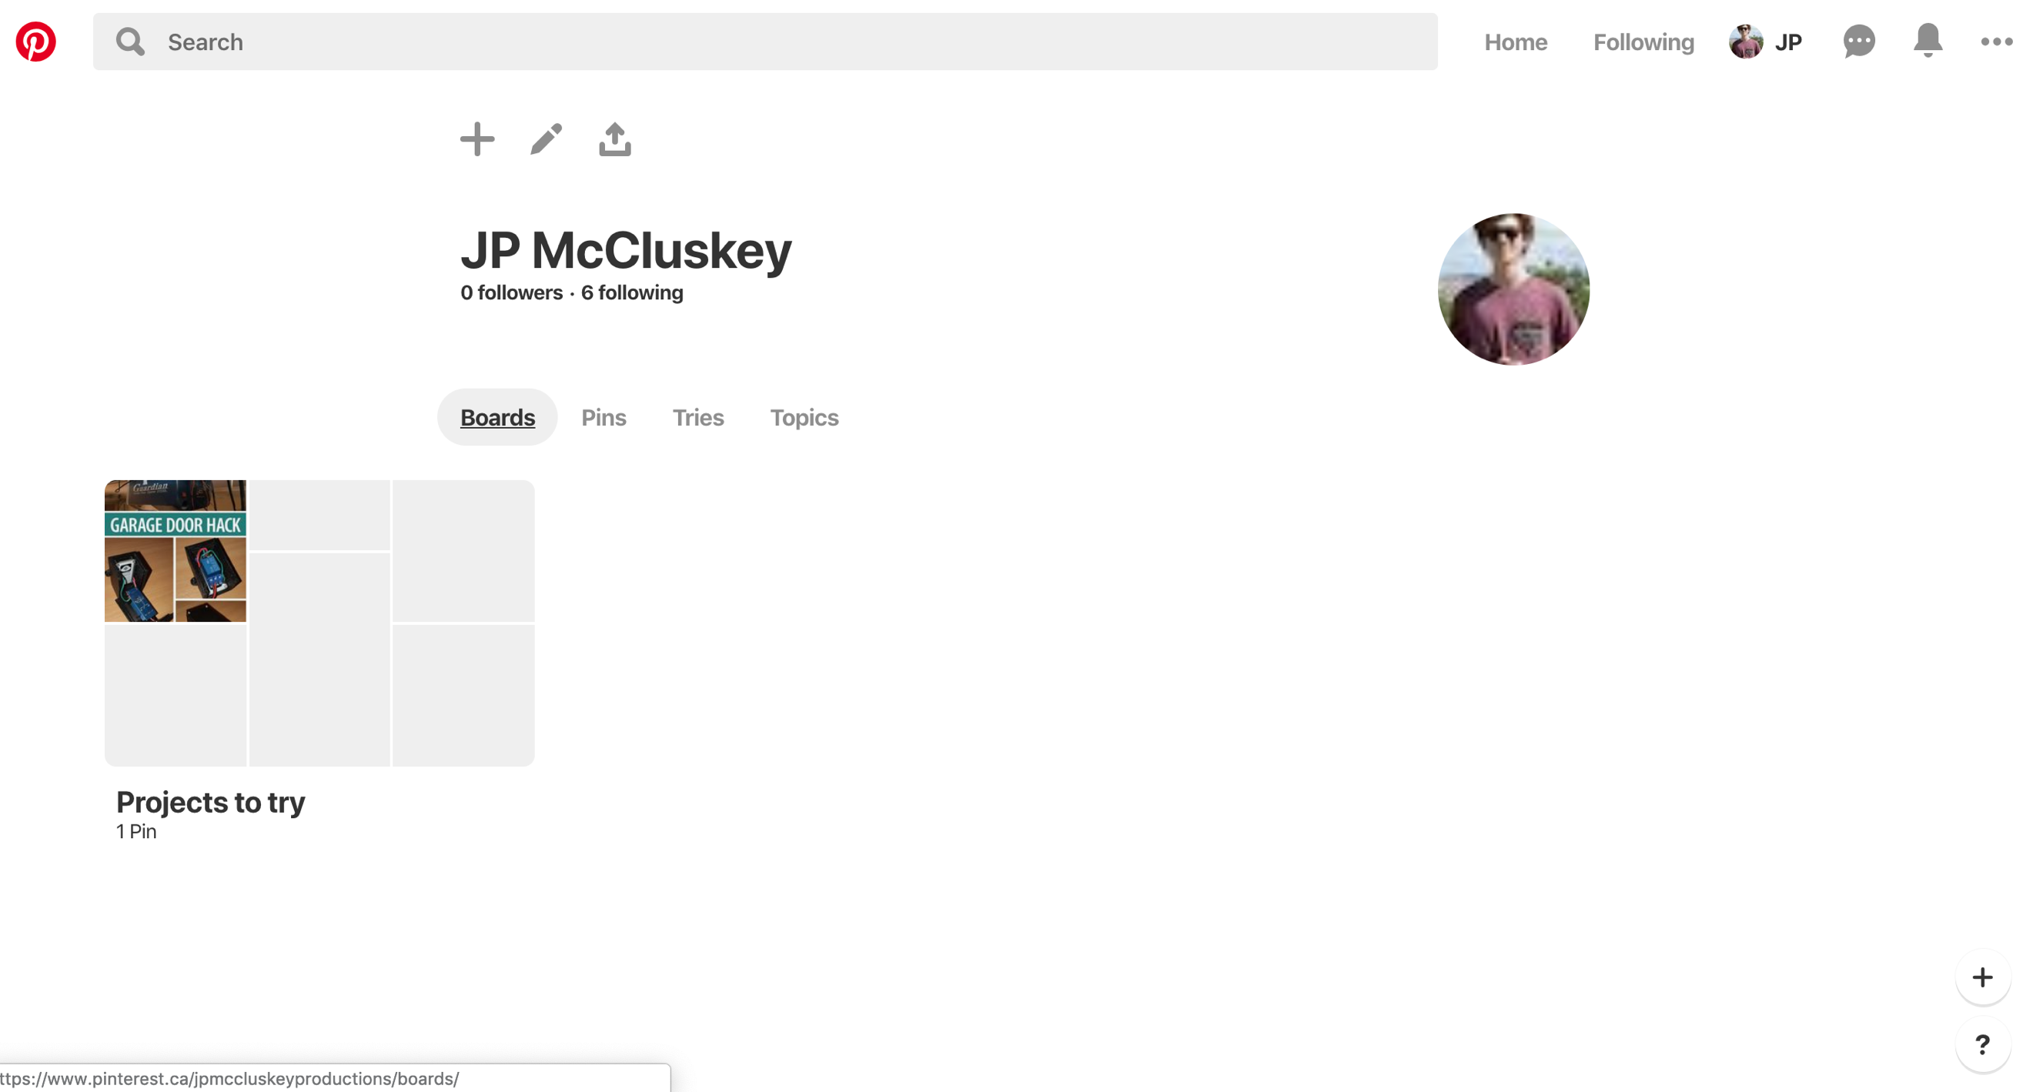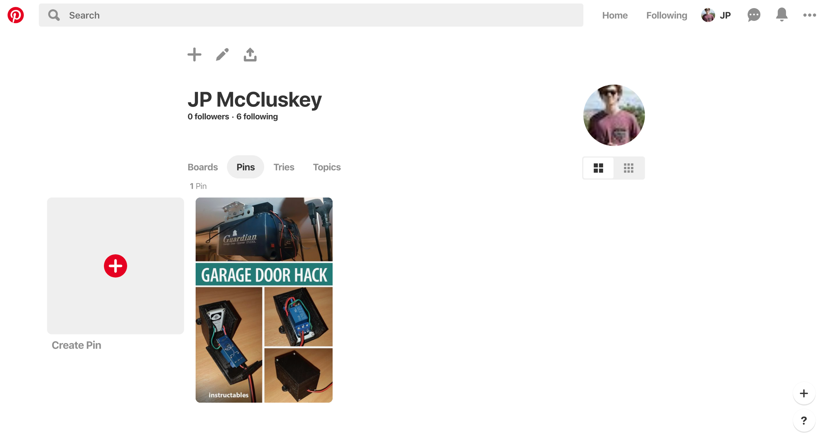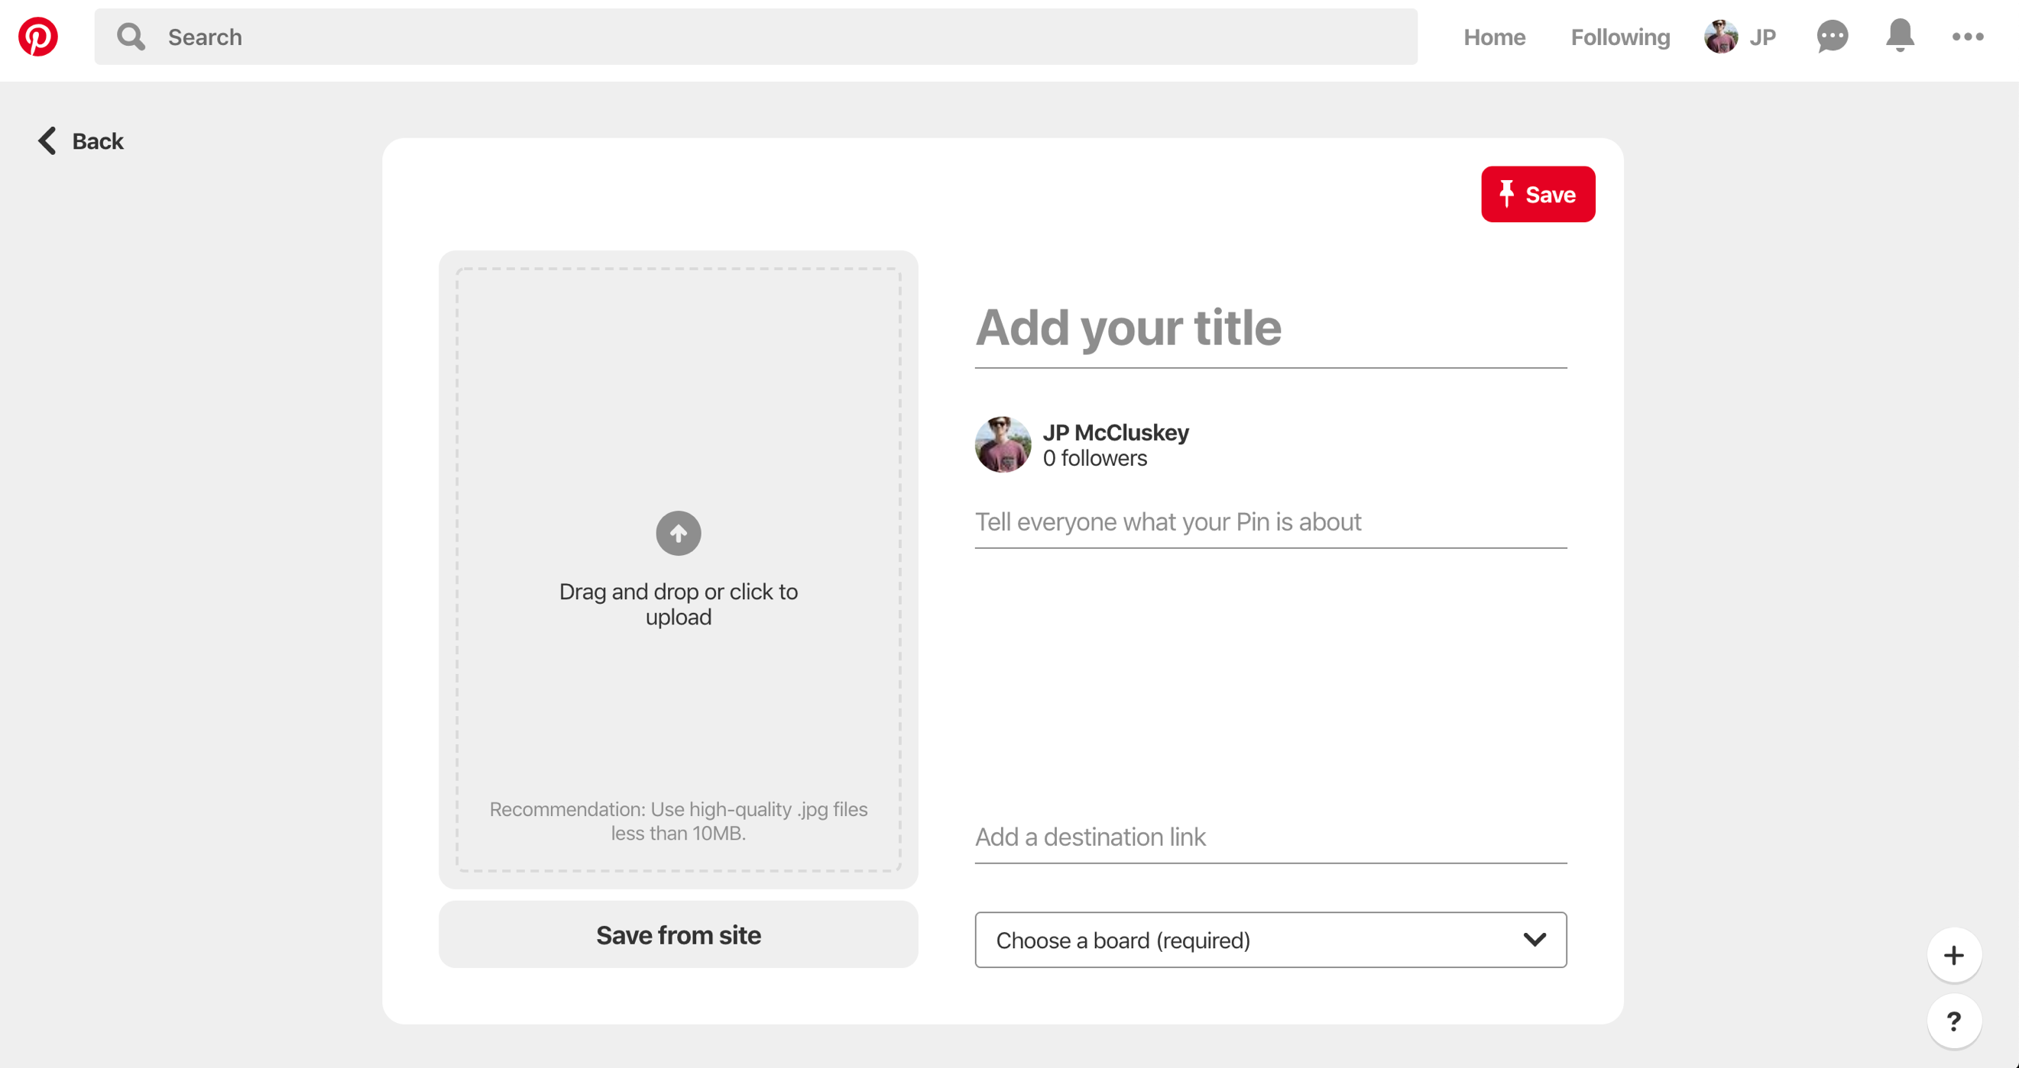

Figure 11: adding photo form

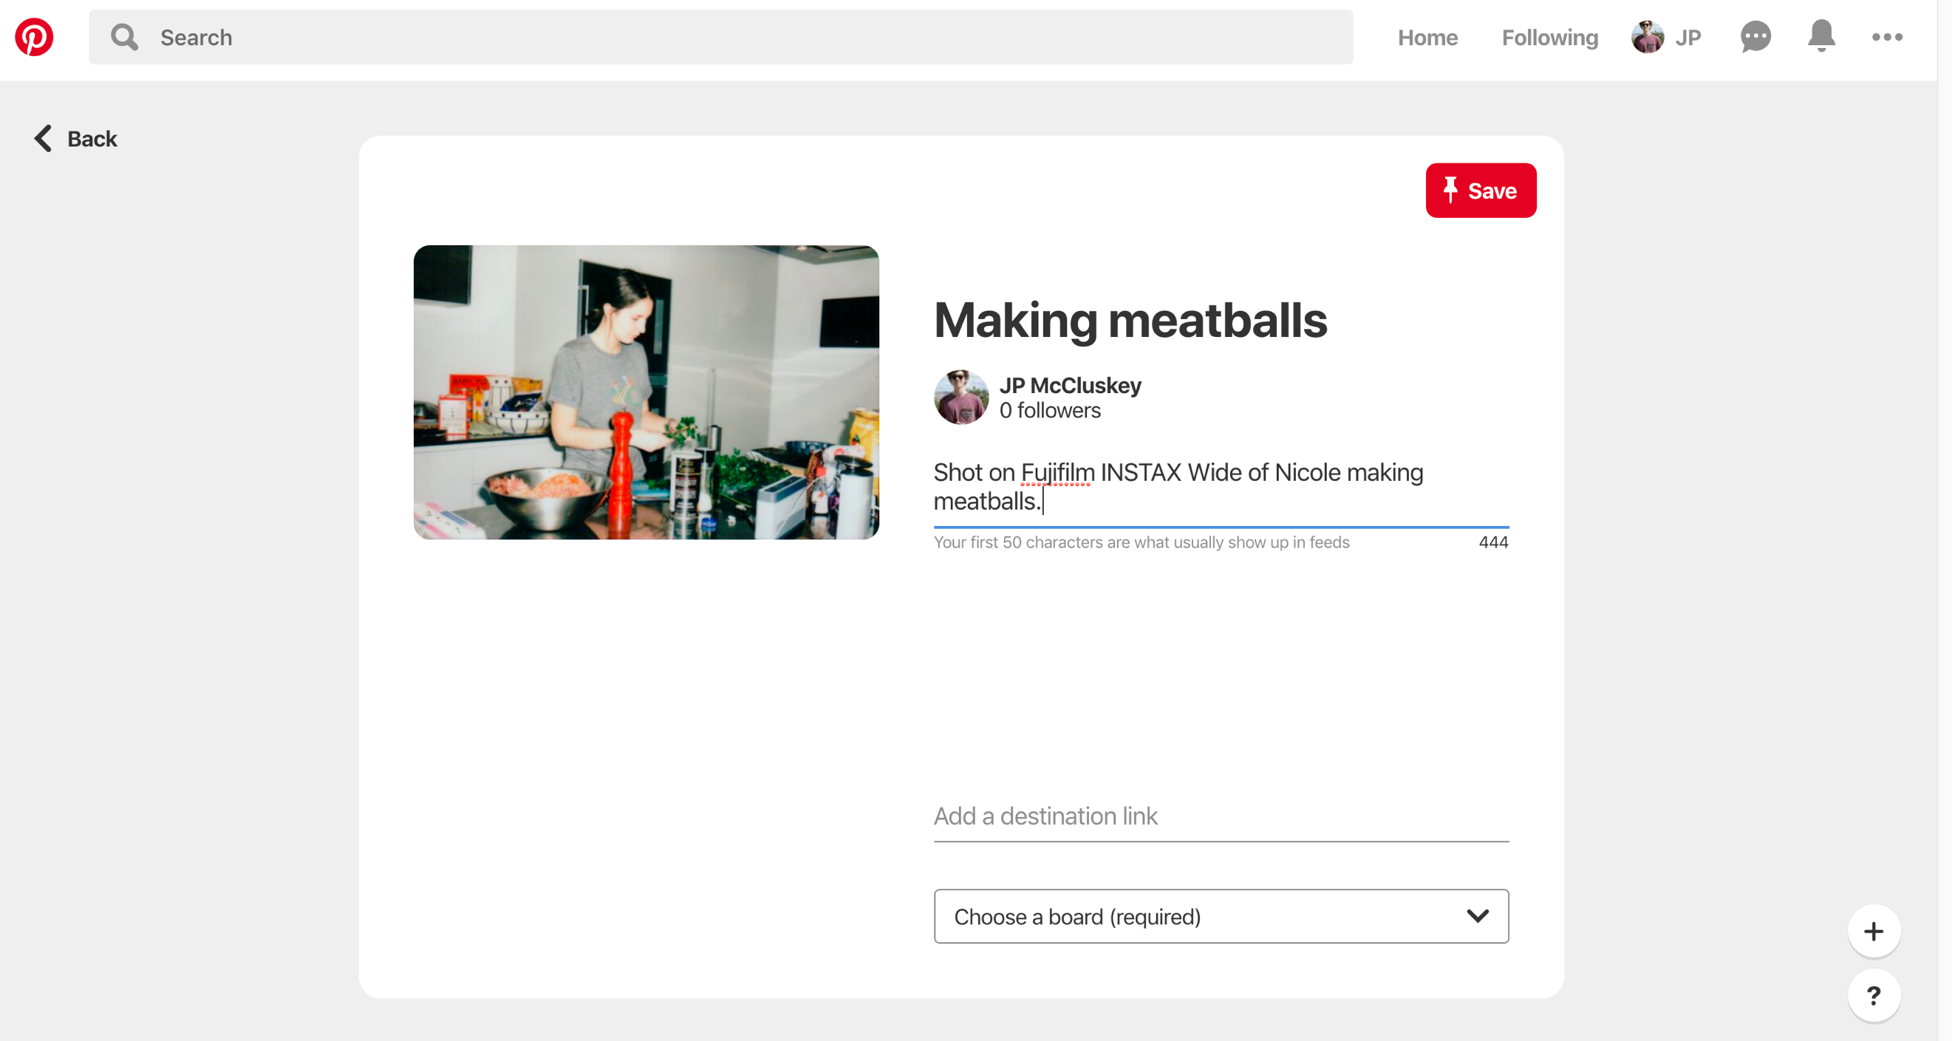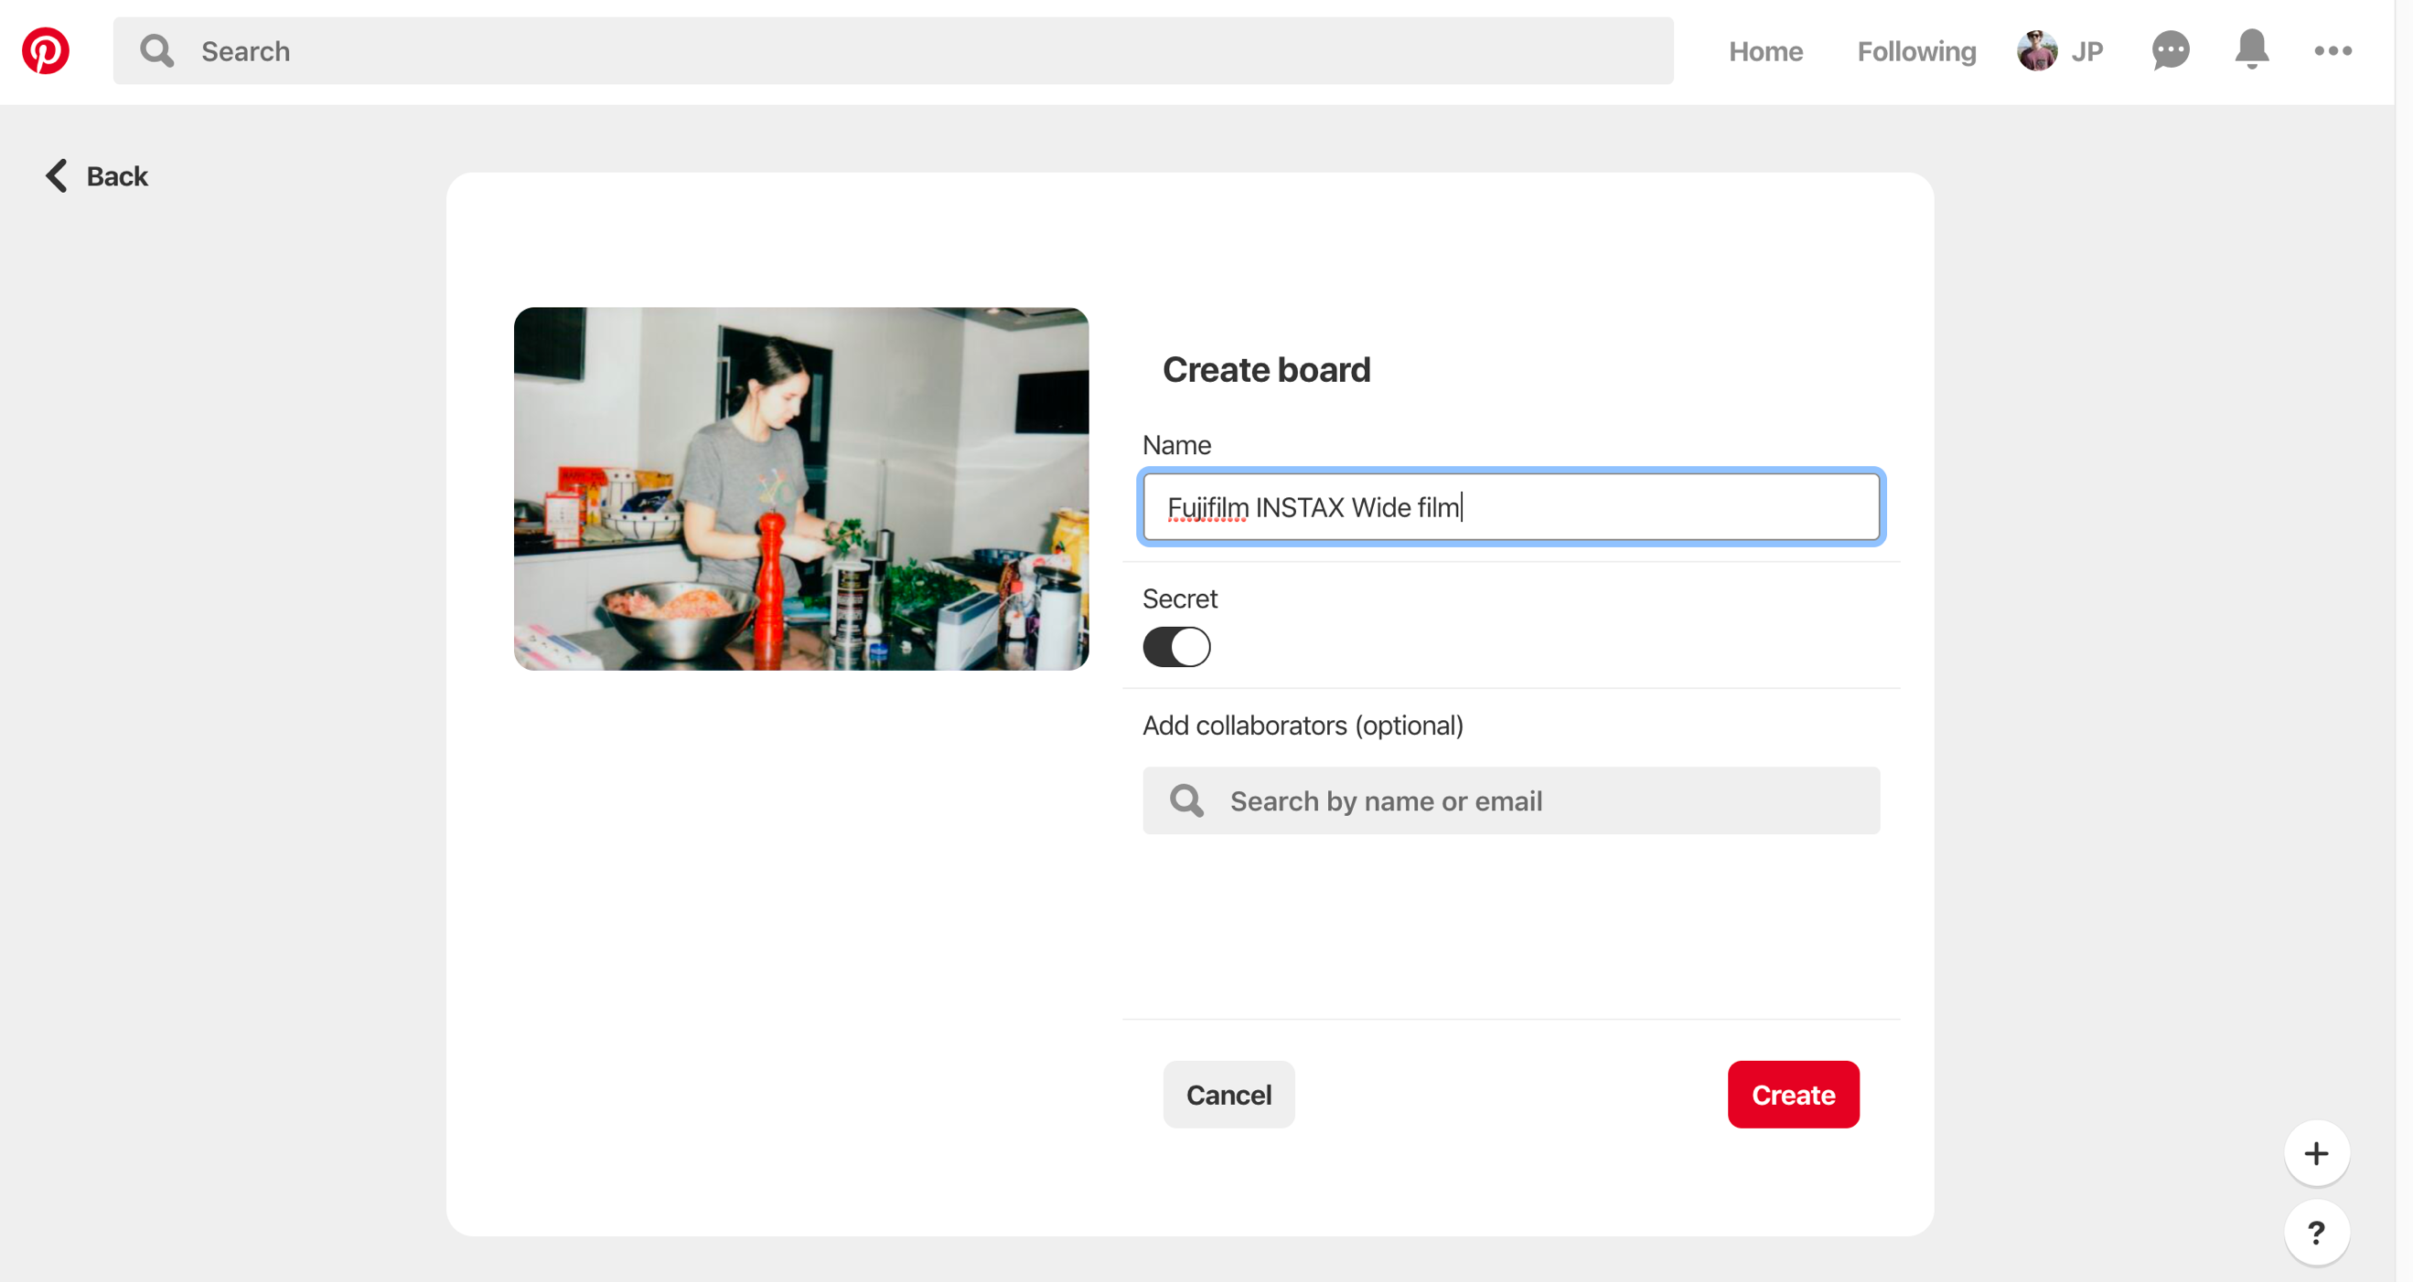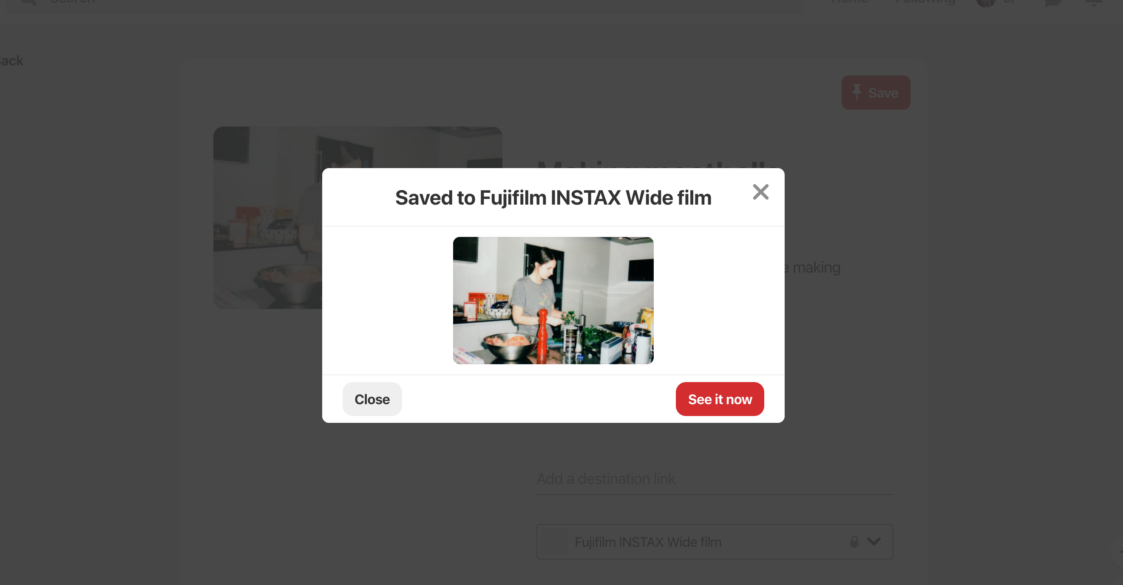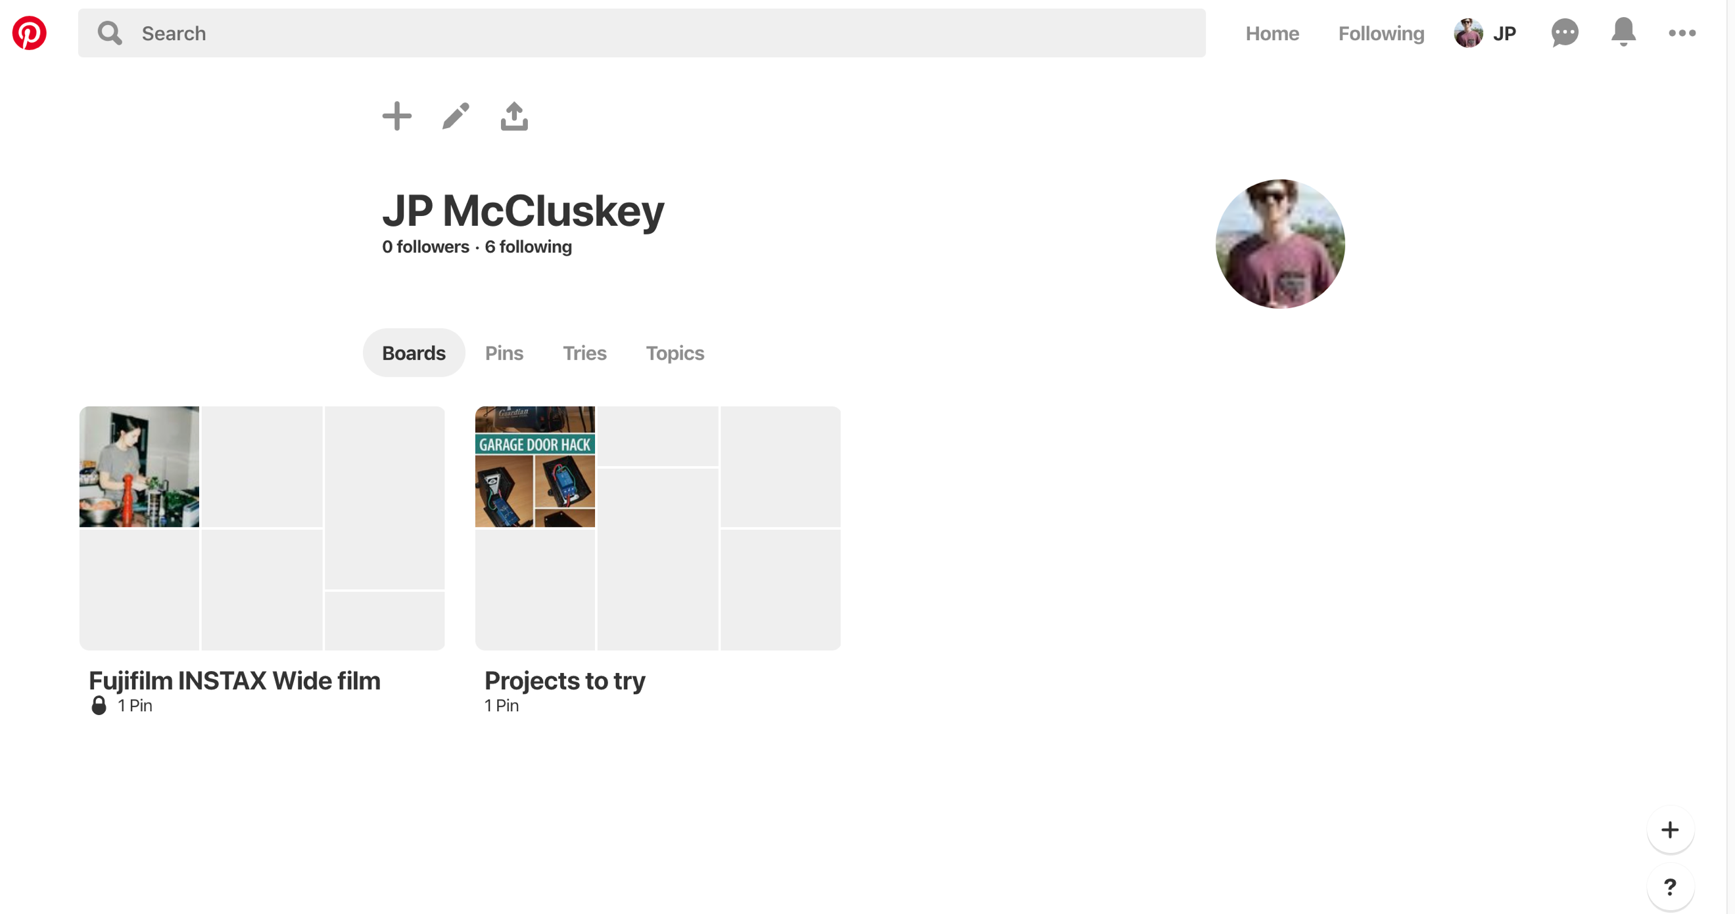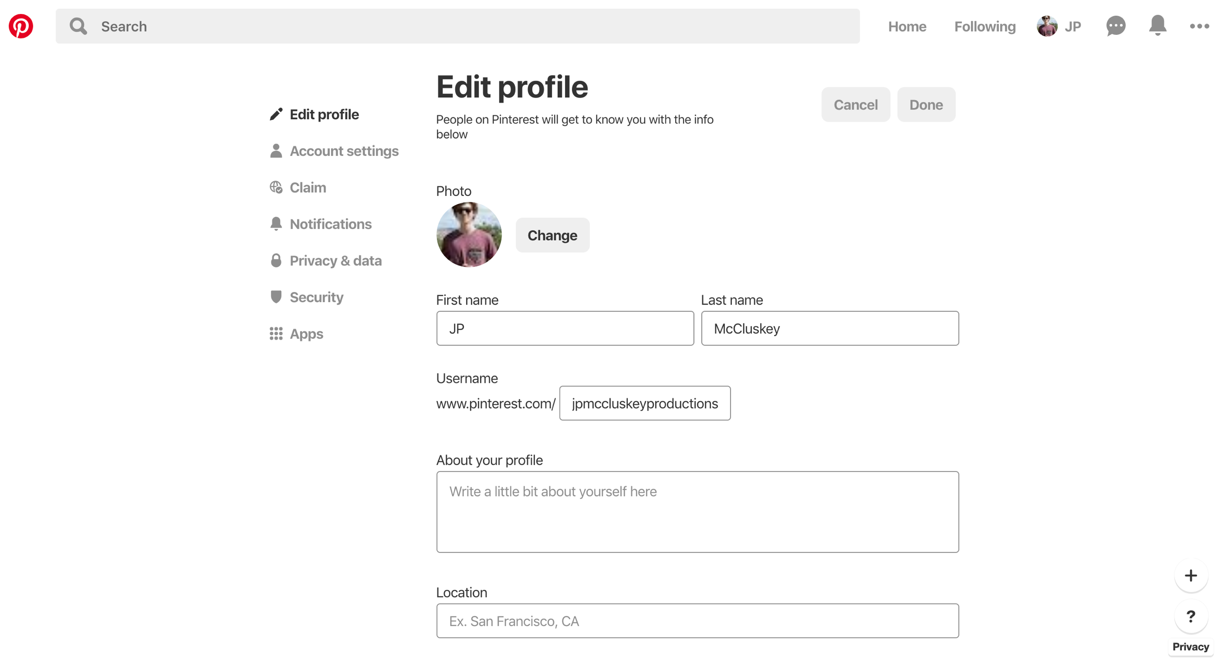

Figure 12: profile form

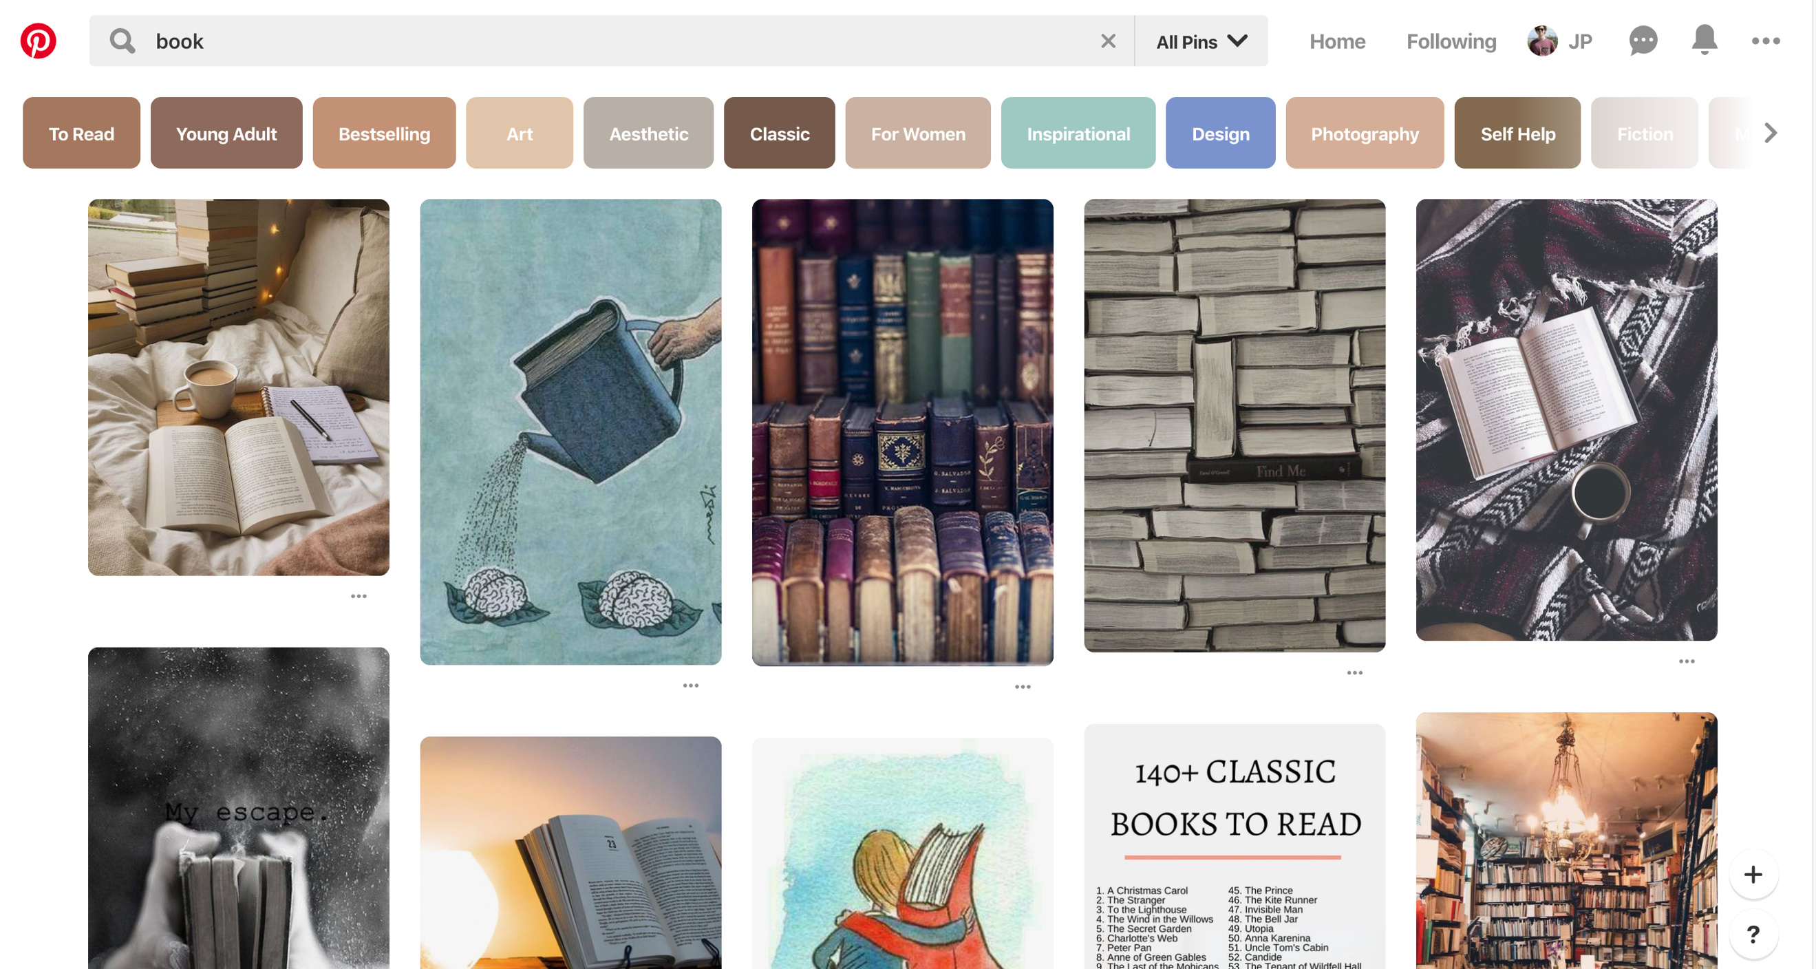

Figure 13: search page

